Data for Landfill Model Validation

* Initial conditions for candidates

|  |  |  |  |  |  |  |  |
| --- | --- | --- | --- | --- | --- | --- | --- |
| NEW |  |  |  |  |  |  |  |
| Active |  |  |  |  |  |  |  |
|  | NoWTE | CF | Elec | CNG | PNG | BCFuel | TCFuel |
| LFSmall | 89 | 48 | 79 | 0 | 0 | 0 | 0 |
| LFLarge | 12 | 119 | 251 | 18 | 0 | 0 | 0 |
|  |  |  |  |  |  |  |  |
| Inactive |  |  |  |  |  |  |  |
|  | NoWTE | CF | Elec | CNG | PNG | BCFuel | TCFuel |
| LFSmall | 55 | 1 | 48 | 1 | 0 | 0 | 0 |
| LFLarge | 11 | 2 | 83 | 3 | 0 | 0 | 0 |

|  |  |  |  |  |  |  |  |
| --- | --- | --- | --- | --- | --- | --- | --- |
| OLD (2013 LMOP) |  |  |  |  |  |  |  |
| Active |  |  |  |  |  |  |  |
|  | NoWTE | CF | Elec | CNG | PNG | BCFuel | TCFuel |
| LFSmall | 122 | 1 | 55 | 2 | 0 | 0 | 0 |
| LFLarge | 44 | 247 | 70 | 2 | 0 | 0 | 0 |
|  |  |  |  |  |  |  |  |
| Inactive |  |  |  |  |  |  |  |
|  | NoWTE | CF | Elec | CNG | PNG | BCFuel | TCFuel |
| LFSmall | 31 | 0 | 91 | 1 | 0 | 0 | 0 |
| LFLarge | 15 | 80 | 216 | 37 | 0 | 0 | 0 |

* The WTE FY 16 Q2 milestone provides a summary of the *potential* methane production from landfills (document attached to email; p. 3)
  + 2,100,000 million British thermal units (mmBtu) per day[1]
* Total capacity, loading, and LFG generated by small and large *candidate* landfills (from LMOP data)
  + Methane calculated assuming LFG is 47% methane and methane heat content is 1,012 Btu/scf

|  |  |  |  |  |
| --- | --- | --- | --- | --- |
| Category | Total design capacity (short tons) | Total waste in place (short tons) | Total LFG Generated (mmscfd) | Calculated methane generated (mmBtu/day) |
| *Large Candidate* | 5,548,283,814 | 939,051,944 | 597 | 283,957 |
| *Small Candidate* | 88,029,101 | 53,665,792 | 24 | 11,415 |
| *Large potential and candidate landfills* | 7,226,549,394 | 1,366,095,137 | 797 | 379,085 |
| *Small potential and candidate landfills* | 251,891,192 | 174799094 | 52 | 24,257 |
| *All Landfills in LMOP[2]* | 20,858,832,863 | 7,423,001,681 | 3,339 | 1,689,534 |

* Average capacity, loading, and LFG generated by small and large landfills (from LMOP data)

|  |  |  |  |  |
| --- | --- | --- | --- | --- |
| Category | Avg. design capacity (short tons/landfill) | Avg. waste in place (short tons/landfill) | Avg. LFG Generated (mmscfd/landfill) | Avg. calculated methane generated (mmBtu/day/landfill) |
| *Large Candidate* | 17,124,333 | 3,161,791 | 2 | 951 |
| *Small Candidate* | 2,095,931 | 1,248,042 | 1 | 475 |
| *Large potential and candidate landfills* | 15,813,018 | 3,154,954 | 1.9 | 903 |
| *Small potential and candidate landfills* | 1,415,119 | 924,862 | 0.6 | 285 |
| *All Landfills in LMOP2* | 18,059,596 | 3,680,219 | 3 | 1518 |

* Percentage of LFG that is methane (stats from LMOP data for all landfills)
  + Average = 47%, Min = 20%, Max = 67%
* Average lifetime of landfills
  + ~51 years (all landfills – including projected closures)
  + ~34 years (for landfills that have already been closed)
* Average % of capacity used when they close (waste in place/design capacity for closed landfills)
  + ~80%
* Are waste exported?
  + I believe the answer is yes but I wasn’t able to find a good source for data on this topic
  + However, I did find EPA data on the amount of waste generated vs. the amount of waste that goes to landfills
    - 258 million tons of MSW are generated but only 136 million of these tons of MSW are landfilled[3]
      * Amount landfilled is determined by the recycling rate and the amount of waste that is currently diverted from landfills and combusted for energy2

|  |  |  |  |  |  |
| --- | --- | --- | --- | --- | --- |
|  | Closures 2000-2005 | Closures 2005-2010 | Closures 2010-2015 | Closures 2015-2025 | Closures 2025-2040 |
| Total | 132 | 110 | 112 | 360 | 399 |
| Per year | 26.4 | 22 | 22.4 | 36 | 26.6 |

* Biodegradable fraction
  + ~67% of MSW is biodegradable[4]
* Decomposable fraction
  + ~59% of biodegradable MSW decomposes during the time that methane is produced (remainder is left as solids)[5]
  + Landfill gas composition changes over time due to changes in decomposition rate (see image on next page)[6]
* Landfill closures (all landfills)
* Landfill openings (all landfills)

|  |  |  |  |  |  |
| --- | --- | --- | --- | --- | --- |
|  | Openings 1980-1990 | Openings 1990-2000 | Openings 2000-2010 | Openings 2010-2020 | Openings 2020-2040 |
| Total | 605 | 311 | 55 | 4 | 0 |
| Per year | 60.5 | 31.1 | 5.5 |  |  |

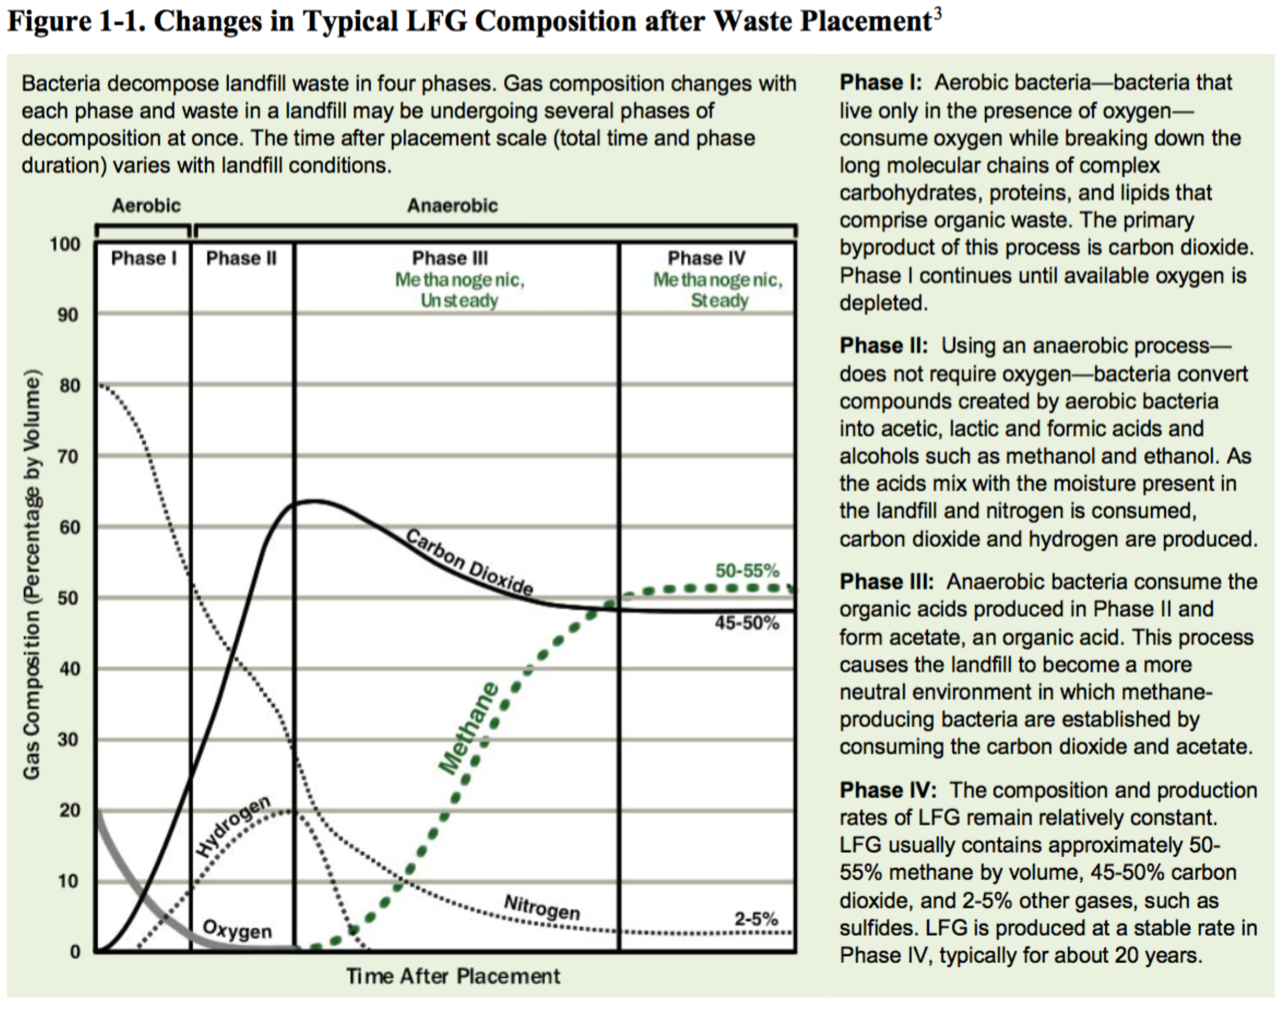

1. These data come from Murray (2014) and Saur and Milbrandt (2014) (also attached to email)
2. Includes all categories including in LMOP data (e.g., open, closed, potential, candidate, operational)
3. Source: <https://www.epa.gov/smm/advancing-sustainable-materials-management-facts-and-figures#Materials>. Original statement/data: *In 2014, in the United States, about 258 million tons of MSW were generated. Over 89 million tons of MSW were recycled and composted, equivalent to a 34.6 percent recycling rate. In addition, over 33 million tons of MSW were combusted with energy recovery and 136 million tons were landfilled.*
4. De La Cruz and Barlaz 2010 Estimation of Waste Component-Specific Landfill Decay Rates Using Laboratory-Scale Decomposition Data
5. These values were calculated by combining the fractional compositon of the MSW stream (U.S. Environmental Protection Agency. 2011. “Municipal Solid Waste Generation, Recycling, and Disposal in the United States Tables and Figures for 2010.” Table 3. EPA-530-F-11-005. Washington, DC: U.S. EPA. Available at

   < http://www.epa.gov/osw/nonhaz/municipal/pubs/2010_MSW_Tables_and_Figures_508.pdf>.) with the extent of decomposition by type of waste stream found in Eleazar et al. 1997 Biodegradability of Municipal Solid Waste Components in Laboratory-Scale Landfills.
6. EPA. 2016 LFG Energy Project Development Handbook.